Pottstown Regional Park Improvement Mini-Grant Program
Acknowledgment Sign Specifications, Language, and Logos

Sign Specifications
Overall size | 18” x 24”
Font Size | Range from .71” to 1.75”
Font Style | Arial
Orientation | Landscape
Base Material | Aluminum
Thickness | 0.080
Sides printed | 1
Corners | Round
Base Color | Green
Text Color | White
Border | Yes
Mounting | At funded project site
Mounting Holes | No
Overlay | EG vinyl

Sign Language

OURTOWN PARK
BOROUGH OF OURTOWN
Funding assistance has been provided by the Department of Conservation and Natural Resources Bureau of Recreation and Conservation and the Pottstown Regional Community Foundation through the Pottstown Metropolitan Planning Commission Mini Grant Program.

Logos

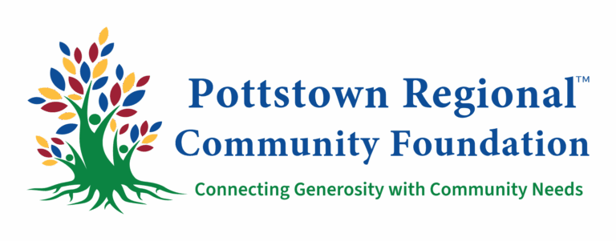



Pottstown Regional Community Foundation branding may be downloaded from their website: https://www.pottstownfoundation.org/Who-We-Are/Brand-Center/
Department of Conservation and Natural Resources logo may be downloaded from their website:
https://elibrary.dcnr.pa.gov/GetDocument?docId=9040669&DocName=horizontal.eps

Example
