Pottstown Regional Park Improvement Mini-Grant Program
Acknowledgment Sign Specifications, Language, and Logos

Sign Specifications
Overall size | 18” x 24”
Font Size | Range from .71” to 1.75”
Font Style | Arial
Orientation | Landscape
Base Material | Aluminum
Thickness | 0.080
Sides printed | 1
Corners | Round
Base Color | Green
Text Color | White
Border | Yes
Mounting | At funded project site
Mounting Holes | No
Overlay | EG vinyl

Sign Language

OURTOWN PARK
BOROUGH OF OURTOWN
Funding assistance has been provided by the Department of Conservation and Natural Resources Bureau of
Recreation and Conservation Keystone Recreation, Parks and Conservation Fund administered through the Pottstown
Metropolitan Planning Commission Mini Grant Program and the Pottstown Area Health and Wellness Foundation

Logos

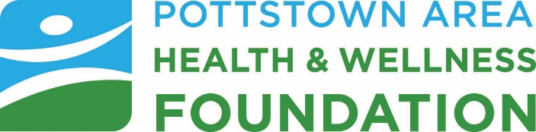


Example
