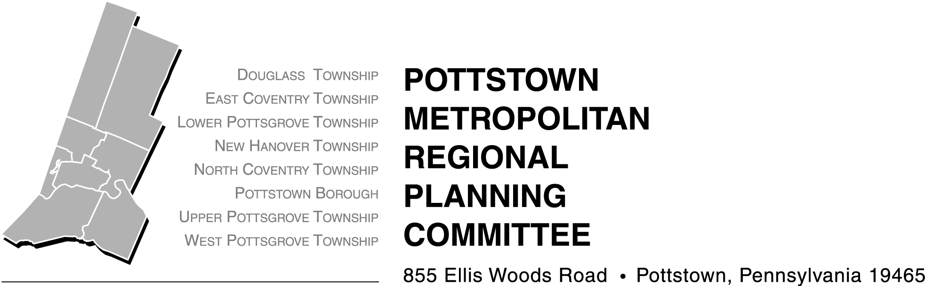




FUNDING

Grant Award:

Total Project Cost:

PARTNERSHIP IS KEY
Please list any partnerships and their contribution to your project - Approximate length: maximum 550 characters and spaces allowed, Ariel 10 point bold

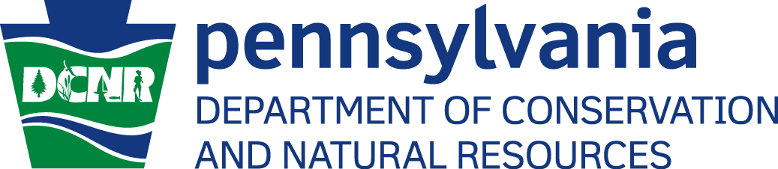

Form approved by DCNR on 6/22/2015

PLEASE INSERT PHOTO TO REPLACE THIS PHOTO PLACEHOLDER WITH A PHOTO THAT BEST REPRESENTS YOUR SPECIFIC PROJECT.
Organization Name Here
SUCCESS STORY
CHALLENGE
Please explain why the project was necessary and what need was addressed in your community through this project, - Approximate length: maximum 1,075 characters and spaces allowed Ariel 10 point. Please provide direct reference to the study “Planning and Design Strategies for Healthy Living, Parks, and Recreation in the Pottstown Area” found at - http://pottstownfoundation.org/media/31768/2010parksrecreationstudy.pdf.
SUMMARY
Brief Summary of Project - Approximate length: maximum 645 characters and spaces allowed Ariel 11 point.

The Project’s Name Here
Contact

Ashley Pultorak
Program Officer for Schools, Recreation & Active Living
Pottstown Area Health & Wellness Foundation
apultorak@pottstownfoundation.org

Donna Fabry
Community Planner
Montgomery County Planning Commission
dfabry@montcopa.org

Insert additional picture here if desired.
RESULTS
If quantifiable please include statistics/If qualitative, please include observations, quotes, etc. - Approximate length: maximum 1,280 characters and spaces allowed Ariel 10 point.
SOLUTION
How your project filled this need - Approximate length: maximum 750 characters and spaces allowed Ariel 10 point.
Place additional photo(s) here – 4 photos maximum (i.e. before, during, after photos)

